Welcome to the MSU Extension Community Change Model

This Community Change model, figure 1, focuses on nutrition and physical activity, but the six-step process applies to many community improvement efforts. Community champions can use the same steps for projects like downtown revitalization, arts and culture, or transportation changes.

Supporting Community Voices for Healthy Choices
This toolkit assists community champions in supporting communities to make thoughtful, lasting improvements that help people choose nourishing foods and stay active. You will find six simple steps to guide your desired change efforts and topic specific examples and resources to help you bring people together, to take action, and to share what you learn along the way. Whether you are a parent, educator, childcare provider, resident, volunteer or local leader, you can help make your community stronger and healthier.
These tools will help your group make simple, realistic changes that save time, reduce the need for retraining, and keep healthy practices in place. They support the people you serve with everyday improvements, help you meet funding or quality requirements, and boost community wellbeing. Because the process is flexible, you can start small, choose what fits your capacity, and build on what already works. Even small steps can create long-lasting benefits for your staff, clients, and community.

Making Healthy Choices Easier
Health is shaped by the places where people live, learn, work, and play and can often be influenced by a community champion. When communities improve access to healthy food, safe places to be active, and supportive environments, it becomes easier for everyone to thrive. Small changes can lead to lasting benefits.

Community Champions
Community champions are trusted local individuals who help activate ideas, bring people together, shape community-driven solutions, and sustain momentum over time. They play an important role in mobilizing community members and helping groups navigate MSU Extension’s six-step model to Community Change.
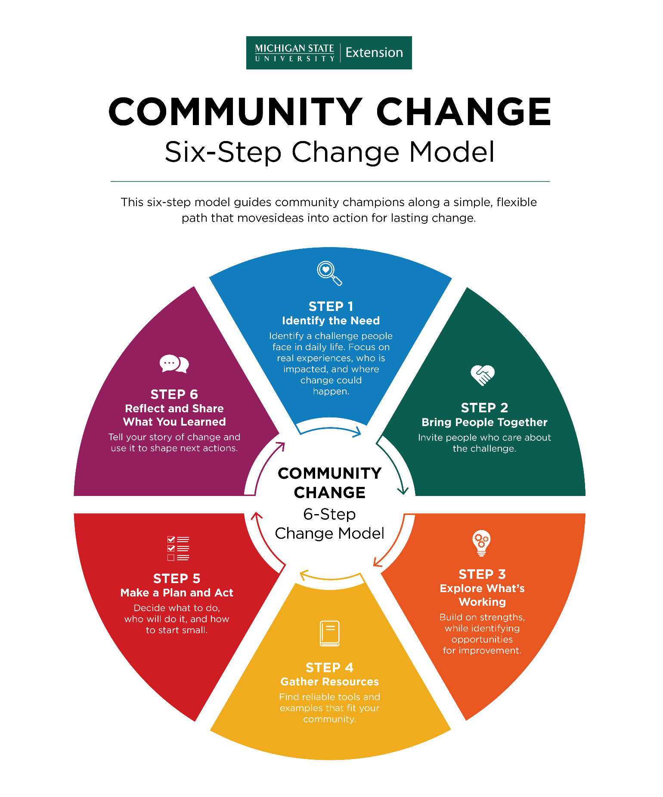
Figure 1. MSU Extension’s Community Change Six-Step Model
In each step below, look for the Community Champion text to understand how champions can support and guide each change process step. Additionally, review the Community Change Hub for curated resources and topic-specific guidance that support change efforts related to championing school wellness, food access, early childhood health, and active communities.

Community Change Model

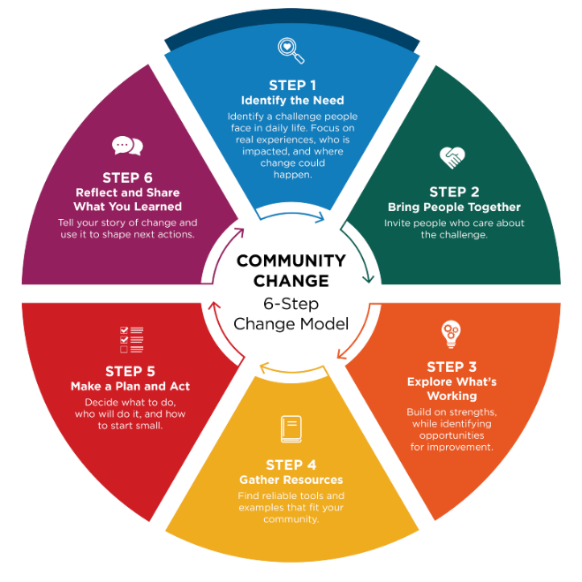
Step 1: Identify the Need

Community champions help bring priorities to light through conversation and observation.

Identifying a need means naming something that makes it harder for people to eat well, access healthy food, or be physically active. You can uncover needs by observing your community, having conversations, and listening to what people care about. A strong community need should:

- Support healthy eating, food access, and/or physical activity
- Affect many people, not just one individual
- Reflect what community members and staff are experiencing and saying
- Name the place or setting where improvement can happen

Support healthy eating, food access, or physical activity

Think about how the need connects to healthier food or opportunities to be active. For example, limited produce options at a local store or a lack of safe places to walk may signal an opportunity for improvement.

Ask:
What challenge or opportunity do you see that relates to eating well or being active?
If you could dream big and anything was possible, what would you change or improve?

Affect many people

A strong need should impact more than one person. Look for patterns or issues that several parents, students, staff members, or neighbors experience. If the need affects a group, it is more likely to create meaningful, lasting change.

Reflect community voices

Talk with staff, partners, community members, and program participants to understand what people are experiencing. Listening helps you learn why the need matters and what the benefits could be.
Open‑ended questions help people share more about their goals and challenges. They also build trust and help you understand the issue in their own words.

Examples of open‑ended questions:
- If things were working really well, what would that look like?
- What are your goals related to nourishing food and physical activity?
- What’s getting in the way of reaching these goals?
- What’s already going well that we can build on?
- What opportunities do you see for change?

Name the place or setting

Be clear about the space where change can happen. This could be a school, neighborhood park, food pantry, community garden, childcare center, workplace, or another local setting.
The clearer you are about what will change and where it will happen, the easier it is to understand the need and support the effort.

Ask yourself:
Where does this need show up?
What specific improvement could make a difference?

Step 1 Worksheet: Identify the Need

Use this worksheet to identify a priority need that reflects lived experience, affects many people, connects to healthy eating/food access or physical activity, and clearly names the setting where change can happen. Community Champions can help surface insights and mobilize early conversations.

1) Choose your focus setting

Where is this need showing up? (choose one)
- A classroom or group of people
- A school building or district or community program site
- An early childhood setting (center, home-based, classroom)
- A community organization (nonprofit, coalition, agency)
- A healthcare setting (clinic, WIC, hospital program)
- A food resource setting (pantry, market, distribution site)
- A workplace or staff team
- A lactation or breastfeeding support setting (lactation room/space, staff/parent supports)
- Other: _____________________________________________________________

2) What challenges or opportunities are you noticing?

Be specific and connect to healthy eating, food access, or physical activity. Example: “Kids sit for long periods,” “Families don’t know where to start,” “Healthy foods are hard to access,” “Staff need support for breastfeeding/lactation.”

What we’re noticing: _____________________________________________________

3) How do you know this is a need and affects many people?

Choose all that apply:
- Staff observations
- Participant/client feedback
- Community feedback
- Data (surveys, participation, incident logs, program data, etc.)
- Policy/compliance requirements
- Other: _____________________________________________________________

4) Why does this matter to our community?

If this issue improved, what would be different?
For participants/community: ______________________________________________
For staff/operations: ____________________________________________________

5) What community voices or perspectives informed this need?

Choose all that apply:
- Community members directly affected
- Staff or volunteers
- Families or caregivers
- Neighborhood or community groups
- Partners or collaborating organizations
- Community leaders
- Data that reflects community experience (Community Health Needs Assessment, local data, etc.)

6) What are the benefits we hope to see?

Choose all that apply:
- Increased physical activity (more movement and less sitting)
- Improved access to nourishing food (food access or food/nutrition security)
- Healthier food and beverage choices
- Improved health and wellness outcomes for participants and families
- Reduced barriers to healthy choices in the organization or setting
- Stronger routines, systems, and supports that make healthy choices easier
- Other: ______________________________________________________________

7) Community champion contribution (who + how)

Which champions helped identify this need and how did they contribute? (Mobilize, Connect): ___________________________________________________________________

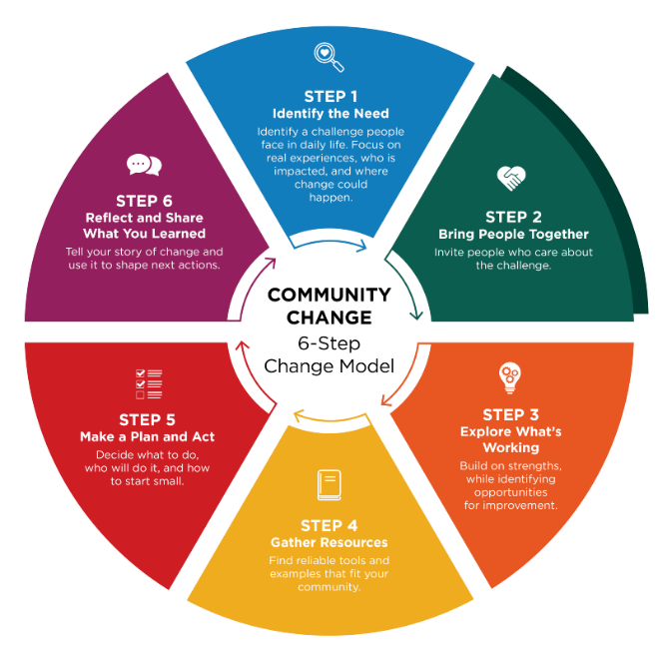
Step 2: Bring People Together

Community Champions often act as connectors who help engage overlooked voices, bridge sectors, and energize others to turn ideas into action.

Real change happens when people come together, talk openly, and listen to those who are closest to the issue. When you create space for honest conversation, about what is working and what could be better, people feel invited to take part. When people feel heard and their ideas matter, they are likely to take ownership. That sense of ownership is what helps change last.

Think about who should be involved

Start by identifying who needs to be part of the conversation from the beginning. Consider people who:
- Care about the issue
- Directly impacted by the issue
- Make decisions or influence how things are done
- Understand how the setting works day to day
- Have valuable insights but may be overlooked
- Are trusted, motivated, and able to help move ideas forward

For example, local law enforcement officers may understand safety issues that affect food pantry outreach. Youth often offer perspectives adults may miss. Some of these individuals may become community champions.
Having people from different sectors—such as schools, nonprofits, health care, businesses, or local government—can help the group share resources and ideas. Using a shared approach, such as the Collective Impact Framework, can strengthen the group’s results.

Questions to help guide your outreach

Ask:
- Who cares about or is impacted by this issue and wants to see improvement?
- Who can help make decisions or influence next steps?
- Who has the time, skills, or resources to support this work?
- Who has strong relationships with the people affected?
- Who could help turn ideas into action?
- Who are the philanthropic partners that might support the work?

Identify someone to guide the process

It is helpful to have a dedicated point person who can guide the group and keep the work moving forward. This individual could be someone from your organization or a partner willing to assist. While partners can provide valuable support and guidance, the organization or group closest to the issue should take the lead in decision-making, driving action, and sustaining the changes over time.

Step 2 Worksheet: Bringing People Together

Identify who should be part of the conversation from the beginning. Community Champions often act as connectors who engage overlooked voices and build trust across sectors.
Folks may come from different sectors across the community, or they may all come from a single organization. Public sectors to consider are:

- Agriculture
- Childcare
- Commercial marketing/local business
- Community design/planning
- Community members (including youth or elders)
- Education (school, after-school programs)
- Food industry (producers, distributors, and processors)
- Food retailers (grocery, corner store, farmers market)
- Government (local, county, tribal, state)
- Health care (clinics, hospitals, educators)
- Local Food Policy Councils or networks
- Media
- Neighborhood groups
- Public health
- Public safety
- Social/human services
- Transportation

Who should be involved?

Sector/Group | Specific Individuals or Organizations | Champion(s) to Engage | How We’ll Invite/Engage

Champion support in step 2

Choose all that apply:
- Community Champion identifies missing voices
- Community Champion makes introductions and warm invites
- Community Champion helps build norms that welcome everyone
- Community Champion co-facilitates early conversations

Reflection

- Who are the people impacted by the issue and how will their voice be heard?
- Do you have the right people at the table? Are any key people or sectors missing from your list who can help make decisions and influence next steps?

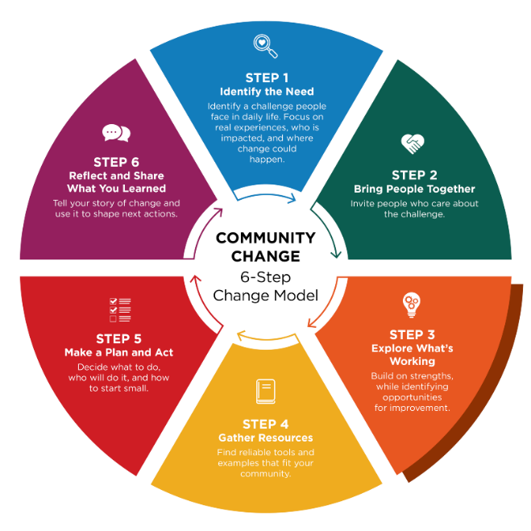
Step 3: Explore What’s Working

Community Champions contribute insight into what has worked before, ground options with real needs, and help define what matters most to the community.

Before choosing your next steps, it helps to understand what things look like right now and what has worked well in the past in your community or other communities. This means paying attention to what is already helping, what has been successful, and what might be getting in the way. When you understand current conditions, you can make thoughtful decisions about where change would be most useful.

Look at everyday practices and spaces
With your partners, take time to observe the setting, talk through routines, and think about the places where people spend time. This helps you notice strengths, gaps, and opportunities for improvement.
You may find it helpful to keep a list of guiding questions on hand during your discussion. Questions like these can get the conversation started:

- What’s working well—and what has worked well in the past—that we can build on?
- Are there current practices we could improve?
- Where do people feel stuck or frustrated?
- Are there patterns or gaps that seem important to address?
- Are there opportunities to make healthy choices easier?
- What changes have you already been thinking about?
- Is there anything in the data that supports the direction you’ve been considering?
- What would make the biggest difference for clients, students, or the community?

Consider readiness for change

It is also important to think about what nutrition and physical activity changes you are ready to act on. Readiness includes confidence, motivation, capacity, and feeling supported. When people feel ready, changes are more likely to stick.

By understanding both what’s happening at your site currently and how ready your team is, your team can choose the next steps that feel realistic, meaningful, and doable for the group.

Use tools or structured approaches when helpful

In some situations, tools can help organize the conversation. For example, Appreciative Inquiry is a process that focuses on what is going well and how to build on those strengths. In other cases, simply having a goal-oriented discussion or walking through the setting together can help people notice what could improve. Choose an approach that helps people feel comfortable sharing ideas and noticing possibilities.

Step 3 Worksheet: Explore Options

During conversations with the group, it may be useful to capture their perspective on:
- What’s working right now or has worked?
- What feels true about the current situation?
- What you hope things could look like in the future?
- What might make it hard to get there?
Community Champions help ground insights into lived experience and support facilitation.
Activity

Write each of the four headings (see below) on large sheets of paper and post them around the room. Give each person sticky notes and ask them to write one idea per note. Then have them place their notes under the heading that best fits their idea. After all the notes are posted, read them out loud together. If something isn’t clear, ask the person who wrote it to explain. You can also group similar ideas to see patterns. If helpful, a neutral facilitator can guide the conversation and make sure all voices are heard. MSU Extension is available to support community groups through visioning and action planning.

Community champion contribution

- Community Champion shares context on prior efforts
- Community Champion helps connect ideas and voices
- Community Champion ensures perspectives of those most affected are included

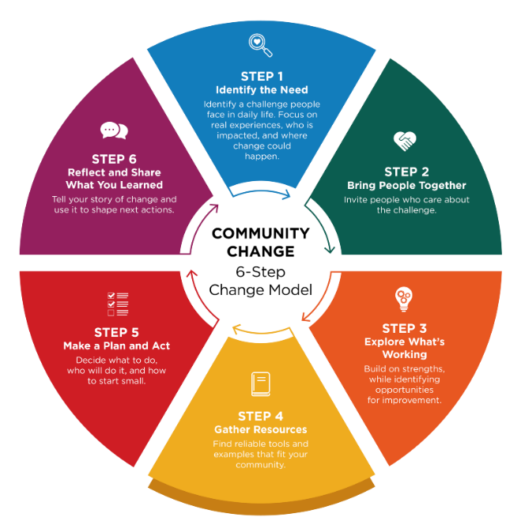
Step 4: Gather Resources

Community Champions often know partners and are passionate about choosing practical strategies that fit the community.

Once you have explored what is working and what could be better, the next step is to decide what your group wants to do. Work together to choose realistic goal(s) and gather information that can help you reach it.

Look for reliable ideas and examples

Start by reviewing trustworthy resources, practical strategies, and real‑world examples. Talk with your group about tools or ideas that could move your goal forward. Ask if anyone knows another place — or a person — who has tried something similar.

You may also want to:
- Visit communities or sites that have used successful approaches
- Connect with community champions who have done similar change work
- Observe what makes their approach effective

Seeing what others have tried can spark ideas and help you understand what might work in your setting.

Use trusted sources

When reviewing online materials, look for resources that highlight research or evidence‑based practices. Reliable, evidence-based information often comes from:

- Universities
- Professional organizations
- Government (.gov) sites

These sources can help you build a stronger, more informed plan.

Talk with your team about what fits best

Discuss what strategies feel like a good match for your group’s goals and readiness. Partners may know about resources that:

- Describe promising or evidence‑based strategies
- Provide funding or financial support
- Help plan or carry out the work

Choose options that feel realistic and doable for your group.

Questions to consider

As your group begins planning, the following questions can help clarify what’s required and where to focus your efforts. Ask:
- What does the group want to change?
- What resources are needed for success?
- Will financial support be needed?

Tip: Consider using a facilitator

It may be helpful to invite an outside facilitator for your first meeting. A trained facilitator can guide the conversation, help generate ideas, identify challenges, and make sure all voices are heard—especially when the group has diverse needs. MSU Extension does support community groups through visioning and action planning.

Step 4 Worksheet: Gather Resources (Start to Build a Plan)

Choose strategies that fit your setting and identify tools/partners to support action. Champions help determine fit, connect to resources, and communicate the plan.

1) What kind of change are you trying to make?

Choose one or more that apply. This helps identify strategies that last.

- Change the rules or expectations (guidelines/standard practices)
- Change the routine (schedules, workflows, checklists, or meetings)
- Change the space or what’s available (supplies, signage, room setup)
- Not sure yet

2) Decide on ONE clear goal to focus on first.

Goal: ____________________________________________________________________________

3) Explore what works

Review the suggested examples and strategies provided in the Community Change Hub Champion Early Health, Champion School Wellness, Champion Food Access, or Champion Active Communities.
Idea 1: ___________________________________________________________________________
Why it fits: ________________________________________________________________________
Idea 2: ___________________________________________________________________________
Why it fits: ________________________________________________________________________

4) What barriers might get in the way?

- Time
- Space
- Staffing
- Money
- Buy-in
- Knowledge/skills
- Other: ___________________________

5) Choose ONE resource from step 3 to guide your next step

Resource name: ___________________________________________________________________
What you plan to use from it: _________________________________________________________
Look for (what you plan to click/use): ___________________________________________________

Reflection

- Are there barriers to moving forward such as readiness, time, money, people you have at the table? If yes, should you identify a different goal?
- Do your resources support moving forward?

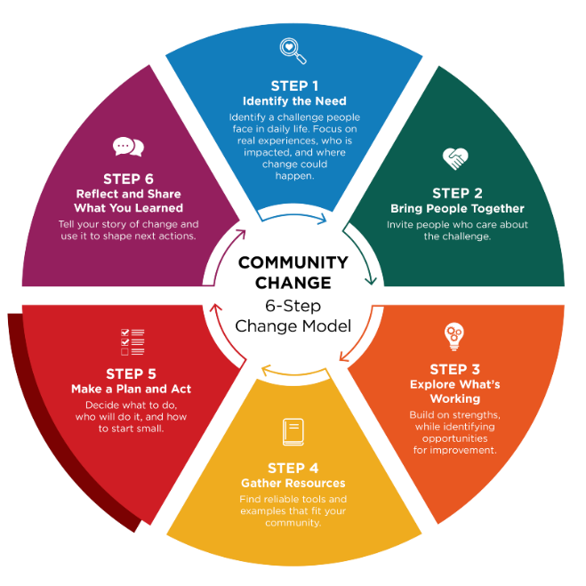
Step 5: Make a Plan and Act

Community Champions can help activate early wins and encourage participation.

Once you know what change you want to see and decide on a goal (see Step 4), the next step is to create a plan to make it happen. An action plan turns ideas into concrete steps and is created by the people who care about the issue and can help move it forward. It helps to begin with the desired change and decide on a goal that feels doable, useful, and meaningful for the people involved.

Break a big goal into small, manageable steps

The purpose of an action plan is to make the work clear and realistic. Each step should:
- Describe what needs to be done
- Name who is responsible
- Include a timeline
- List what is needed for success
- Identify who needs to stay informed

A strong action plan answers questions like:
- What small steps could help us reach our goal?
- What are we going to try?
- Who is responsible for each task?
- When will changes be made?
- What help or resources do we need?
- Who needs to know about the work as it moves forward?

Considering a written policy or updating a current policy?

A written policy helps guide behavior and decisions by clearly stating expectations and procedures. It can be a useful strategy for creating and maintaining desired change. Policies can range from simple statements to more detailed documents but ultimately serve as a supportive framework. The Step 5a Worksheet provides a policy writing template and an example policy.

Keep the plan flexible

An action plan is a living tool. As the work begins, the plan should be revisited and updated. Adjusting the plan helps the change team stay focused on what is working and respond early to challenges or new opportunities.

Using the action plan during regular team check-ins supports follow-through and keeps the group moving forward.

Tip: Use regular check-ins to build momentum

Check-ins help the team stay connected, motivated, and ready to adapt. During check-ins, you can:
- Celebrate early successes
- Identify challenges or new ideas
- Adjust the plan as needed
- Discuss next steps

Step 5 Worksheet – Action Planning Template

Our Goal:

Here’s an example segment of an action plan with a goal of increasing 1-2 daily physical activities by establishing regular movement breaks into the day in an elementary school.

What action needs to be taken? | Who will be responsible? | When will this be done? | What resources are needed for success? **
Introduce the initiative, share activity ideas with teachers. | School wellness coordinator | Introduce the plan at the next staff meeting. | -The district wellness policy  -A list or menu of simple movement activities
Choose daily movement break times. | Teachers | A week before school-wide implementation | -Menu of movement activities
Implement movement breaks school wide. Coordinator visits classrooms to support implementation. | Teachers with support from coordinator | October 1 | -Posters or cards with movements
Track participation and gather feedback from teachers and students. | Coordinator | November 15 | -Digital participation tracker and simple student survey
Review progress and adjust activities as needed. | Coordinator with school leadership | December 1 | -Results of participation and student feedback

What action needs to be taken? | Who will take responsibility | When will this be done? | What resources are needed for success?
Quote: Great things are done by a series of small things brought together – Vincent Van Gogh

Early win

Can an early win be planned and used to build momentum? How will it be shared?
Possible early win: _________________________________________________________________
How will it build momentum: __________________________________________________________

Communication & check-ins

As action is taken, consistent communication with those that are involved and those that need to be aware is recommended. Consider who needs to know, how often will plan review be done, and how will progress be shared?

Communication Plan or Group Check-ins

Who needs to know? | Frequency | How shared

Step 5a Worksheet – Policy Development

A policy is simply a clear, written statement that explains what a group plans to do, how they will do it, and who it will cover. A good policy makes sure that everyone is involved and on the same page.
Writing a policy can be a very simple to very complex process, depending on the desired outcome. Below are 10 things to consider when writing a policy.

1. Policy title

A policy name can alert the reader to what and who the policy will cover.

Name of your policy: _________________________________________________________________

2. Purpose

The policy should explain how healthy eating, regular physical activity, or access to nutritious foods will be supported in the community. Consider a goal that makes it easier for people to choose and have access to healthy foods or stay active in safe, welcoming spaces.

Purpose of your policy: ______________________________________________________________________________________________________________________________________________________________________________________________________________________________________________________

3. What this policy covers

Decide what your policy applies to. Examples may include food and beverages that are provided or sold; nutrition education and messaging; or physical activity opportunities and spaces. It should also identify who the policy will affect. Consider staff, participants, visitors, or community members.

Policy coverage: ______________________________________________________________________________________________________________________________________________________________________________________________________________________________________________________

4. Key terms

Consider including key terms that need to be defined in the policy. Examples may include definitions like these:
- Healthy foods: Foods that are rich in nutrients, such as fruits, vegetables, whole grains, lean proteins, and water.
- Physical activity: Any movement that helps the body stay strong and healthy, like walking, stretching, or playing sports.
- Supportive environment: A place that is clean, safe, and makes healthy choices easy and accessible.

Key terms to include in policy: ______________________________________________________________________________________________________________________________________________________________________________________________________________________________________________________

5. Our commitments

As the policy is being written, identify what is being committed to. Examples may include:
- Offering and promoting healthy food and drink options
- Encouraging regular physical activity
- Making sure spaces are safe and welcoming for movement
- Providing clear, simple information about healthy choices
- Supporting people of all ages, abilities, and backgrounds

Commitments to include are: ______________________________________________________________________________________________________________________________________________________________________________________________________________________________________________________

6. Actions we will take (to put the policy into practice)

As a result of the policy being written, what actions need to happen and when? Below are a few suggestions that can be used:

Nutrition Supports
We will:
- Provide healthy food and drink options at events, meetings, and programs
- Limit sugary drinks and less healthy snacks
- Make water available and accessible at all times
- Share easy-to-understand nutrition information
- Support breastfeeding and safe infant-feeding practices (if relevant)
- Establish a salad bar in our cafeteria

Physical Activity Supports
We will:
- Provide safe indoor or outdoor spaces for movement
- Encourage activity breaks during long meetings or programs
- Offer or promote walking groups, fitness classes, or active play
- Make sure activities are inclusive and accessible for all abilities
- Promote active transportation when possible (walking, biking)
- Make the school playground available for use during afterschool hours

Policy actions to take will be: ______________________________________________________________________________________________________________________________________________________________________________________________________________________________________________________

7. Roles and responsibilities

As the policy is being developed, it is important to determine who will be responsible for what actions. Here are a few examples to consider:
- Leadership: Makes sure the policy is followed and provides resources
- Staff: Models healthy behaviors, supports activities, and reports concerns
- Participants/Community Members: Use spaces responsibly and share feedback

Who are the people and what are the responsibilities to make the policy successful? ______________________________________________________________________________________________________________________________________________________________________________________________________________________________________________________

8. Reporting concerns

Once a policy is written, determine what options are available for people to report their concerns.

Outline who can report a concern about the food, beverage, or physical activity spaces. For example, include how reports can be made and how they will be resolved:
- Speaking with a staff member
- Calling the main office
- Using the online or written reporting form

We will review concerns promptly and take action. How will concerns be handled: ______________________________________________________________________________________________________________________________________________________________________________________________________________________________________________________

9. Monitoring and success tracking

Once the policy is written, it will be important that it is reviewed regularly and updated if warranted. Include how this will be done. An example is:

We will regularly:
- Review the types of foods and drinks offered
- Check the condition and safety of activity spaces
- Ask for feedback from staff and participants
- Update this policy as needed

The policy will be reviewed and evaluated in the following way: ______________________________________________________________________________________________________________________________________________________________________________________________________________________________________________________

10. Communication

Informing staff, volunteers, and community members is important to show the investment being made, through the policy, in the health of the community. A simple statement will let the community know what to expect. Consider a statement like “We will share this policy with staff, participants, and community members. Updates will be posted in common areas and on our website.”
Policy communication plan: ______________________________________________________________________________________________________________________________________________________________________________________________________________________________________________________

Below is an example policy. Look for the various components mentioned above.

Policy example: A workplace writes a policy that supports adequate time and location for employees to breastfeed and/or pump at work.

ELG Factory Lactation Accommodation Policy
The ELG Factory is a breastfeeding-supportive employer. In accordance with the Federal PUMP for Nursing Mothers Act and the Michigan Breastfeeding Antidiscrimination Act, this company provides reasonable breaktime and appropriate accommodation for employees who need to express breastmilk during the workday. Employees may access these accommodations for as long as they choose to breastfeed or express milk.

All employees at the ELG Factory will:
- Be provided with a place to breastfeed or express their milk in a private space that is not a bathroom. It will be clean, functional for pumping, and shielded from view.
- Have an available refrigerator space to safely store their expressed breastmilk.
- Be provided with flexible breaks to accommodate breastfeeding or milk expression.

This policy will be applied to all employees who need this accommodation and will be implemented and enforced by shift supervisors and human resources staff. Supervisors are responsible for ensuring all their breastfeeding employees have access to these accommodations.

This policy will be reviewed annually by the ELG Health and Wellness Committee at the beginning of every year to ensure ongoing compliance with federal, state, and local laws. This policy is published in the employee manual and will be communicated to all employees in the annual employee update email. This policy information will also be provided to new employees during their onboarding. This policy will be communicated to all shift supervisors during the first staff meeting every year to maintain a supportive work environment for breastfeeding employees.

This policy was last reviewed and updated in March 2026.

Reflection
- Are there any important steps missing from the plan to make it work?
- Will the plan likely lead to the desired change?
- Connecting the dots, will the change meet your identified need?

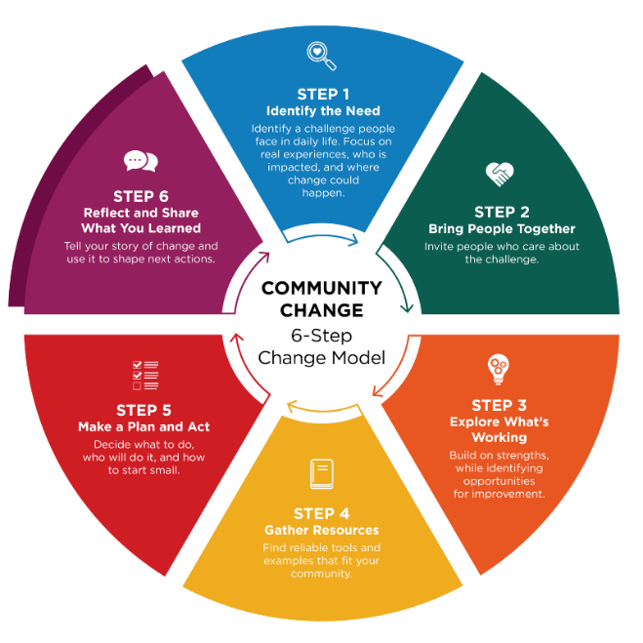
Step 6: Reflect and Share What You Learned

Community Champions often help share the story and celebrate progress.

This step is about looking back and telling the story of what changed. With your team, take time to think about what actions were put into place, what difference those changes made, and what you learned along the way. Taking time to reflect helps everyone see the impact of the work and appreciate the effort it has taken to make the change happen. Reflection can also help you understand what to keep doing, what to adjust, and what new opportunities might exist.

Questions to guide reflection

Ask questions like:
- What changed because of this work?
- How did these changes affect people day to day?
- What worked well, and what was harder than expected?
- What would we do the same — or differently — next time?
- What opportunities does this change open for the future?

These questions help your team understand both the results and the process.

Why reflection matters

Reflection is often skipped, but it is an important part of lasting change. Taking time to acknowledge everyone’s contribution(s) helps people feel valued and keeps them engaged. It also strengthens trust and ownership, which makes it more likely that successful changes will continue. Reflection can also help your group see new needs, ideas, or opportunities to explore next.

Share your story

Highlighting accomplishments with the wider community can build interest and support for future efforts. Sharing your story helps others see what is possible — and may inspire them to get involved.

Step 6 Worksheet: Reflect and Share

Track and reflect on what changed and how to keep success alive. Community Champions help tell the story and celebrate progress.

Success tracking

Goal: ____________________________________________________________________________

What has changed in the community because of our work? What did you try, and how did it go? ______________________________________________________________________________________________________________________________________________________________________________________________________________________________________________________

What felt easy? ______________________________________________________________________________________________________________________________________________________________________________________________________________________________________________________
What felt challenging?
______________________________________________________________________________________________________________________________________________________________________________________________________________________________________________________

Community champion contribution

- Community Champion helped sustain participation
- Community Champion helped navigate setbacks
- Community Champion helped tell the story and celebrate wins

What is ONE sign it worked?

Choose all that apply:
- Participation increases
- Daily routines feel smoother / fewer problems come up
- Staff report it feels easier or more supported
- Participants/families report benefits
- More consistent implementation across staff/site
- Other: _______________________________________________________________________

Success Tracking

Tracking Question | Gathering Information | Summarizing | Reflection
What success have you had? | Participation records, surveys, observations | How many people attended? What changed? | What worked and why? What still needs attention and improvement?
What will you do next?

Choose all that apply:
- Keep it going
- Adjust and continue
- Expand to other settings/groups
- Pause/stop and try something different
- Next step(s): ____________________________________________________________________

What will make it easier to continue and keep this success alive?

Choose 1-2:
- Build it into an existing routine or schedule
- Assign clear ownership (person/team)
- Create a simple checklist or system
- Communicate reminders
- Add signage or visual cues
- Improve access to needed supplies/space
- Other: ________________________________________________________________________
- How we will monitor: _____________________________________________________________

Who could benefit from hearing this? Share what you learned (keep it simple).

- Staff/team
- Leadership
- Families
- Participants
- Community partners
- Other: _________________________________________________________________________

How will you share?

Choose all that apply:
- Quick email
- Brief staff update
- Conversation
- Posting/signage
- Newsletter/social media
- Other: _________________________________________________________________________

Congratulations - you've completed the six steps!

Change doesn’t stop here. Build on your success and use what you learned to identify the next step your community is ready for.

